**Group A**

**Lab Assignment 1d**

### **BDM 1024 - Data Technology Solutions**

Install HDP in VM Ware

Running Hortonworks Sandbox on Virtual Machine.

Creating Sandbox session using Putty.

All the components were monitored in Ambari sandbox available at the local machine at port 8080:

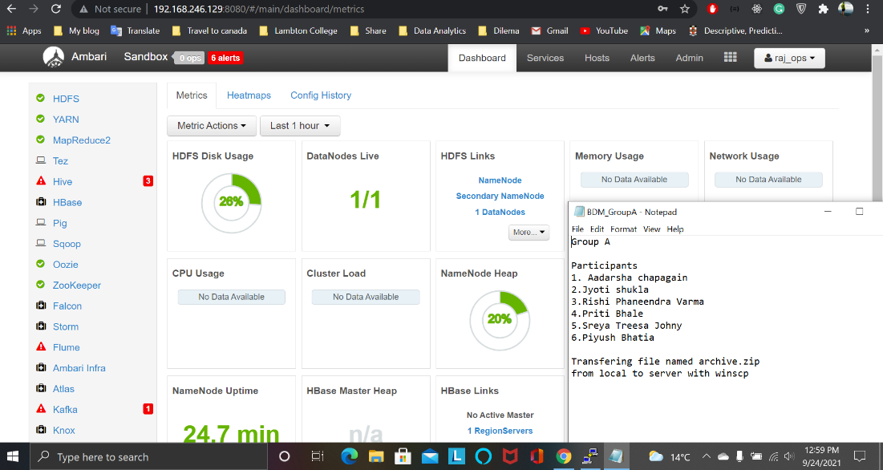

In the second screen shot host is listed as sandbox-hdp.hortonworks

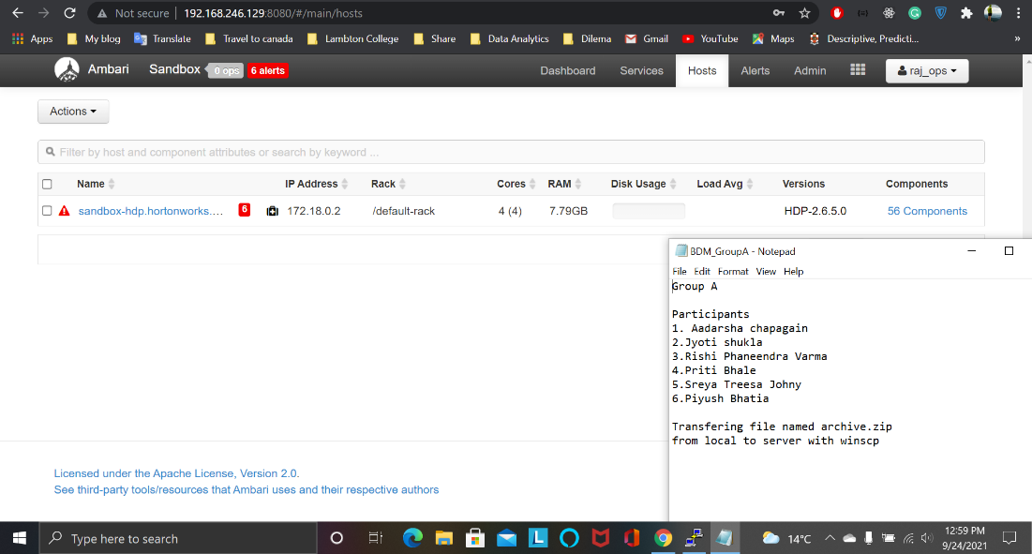

Copying file from local machine to server using winscp. Two files, one jar and and other input files were copied.

Directory named test_data was created under hdfs and input csv file was copied to the same directory under hdfs

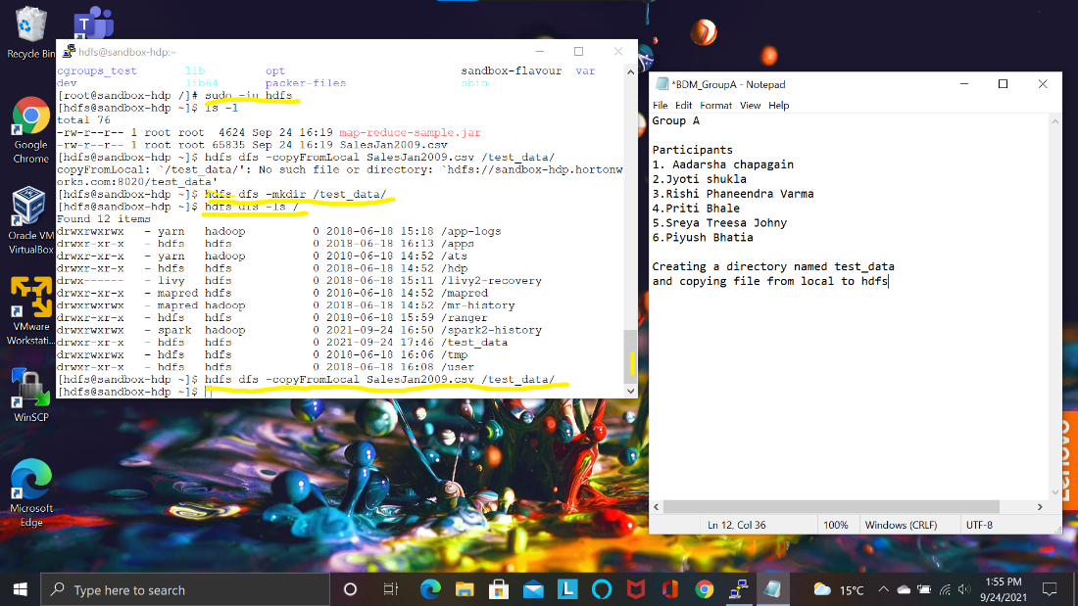

Trying to change permission of the jar file but it was not permitted.

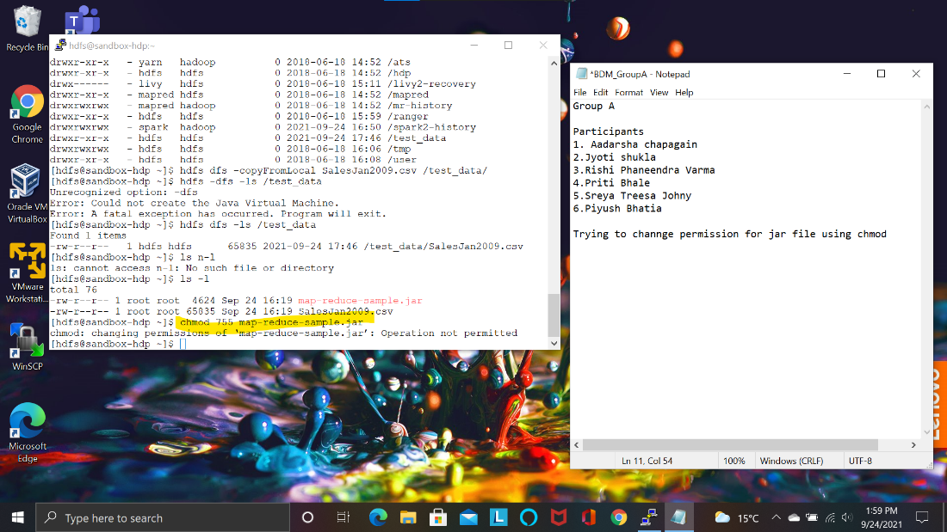

The jar file contained some logic written into it. The input csv file was passed through the jar file using

“hadoop jar <jarfile> <inputfilepathinhdfs> <outputdirectoryinhdfs>

Here directory named mp_output was given as part of path and the directory was created

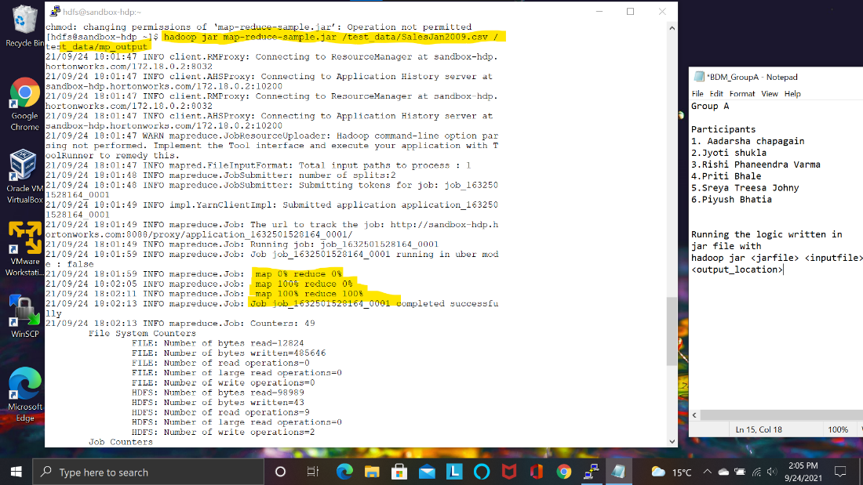

Output from the command showing details of execution

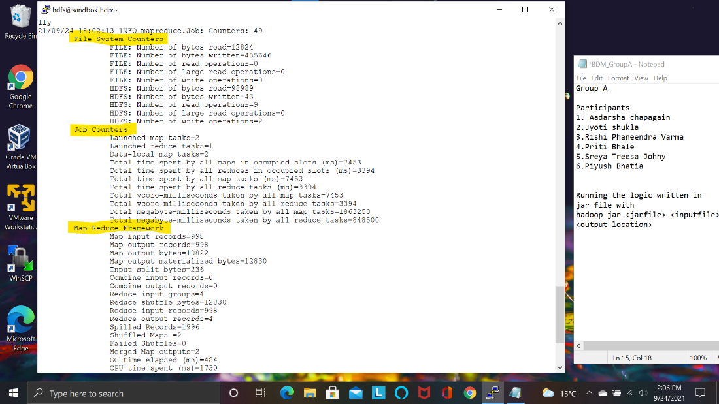

The output was written in the file named part-0000 under the directory named mp_output

as given in command)

It was read using cat command.

Hdfs dfs –cat <filepath>

